Wally Bryer
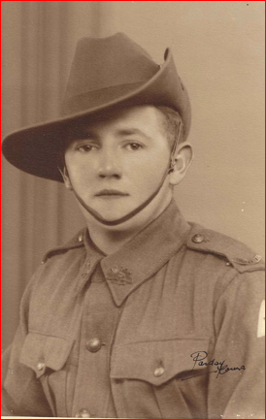
Walter John Bryer (1920-1988)
Pte NX35774 Served 28/6/40 to 21/11/45
2/3rd Pioneer Battalion
Anti-Tank Gun Fitter
Walter Bryer (Wally) was the youngest of 4 children born to Walter and Elizabeth Bryer on 21st March 1920. His older siblings were Frank, Daisy and Betty. Wally was born just 4 days after the family had moved into their new home “Sunnybrae” which was bought as part of a subdivision of Gambarra Station. Gambarra had been subdivided for Soldiers Settlement blocks and were also available for previous sharefarmers for which the Bryers qualified.
Wally’s occupation before he enlisted was as a grazier and he was described as a ‘good shearer and experienced wool classer’ in the book “Gambarra” written by G. Davidson
Wally enlisted in Wagga Wagga in 1940 and joined the 2/3rd Battalion where he became an Anti-Tank Gun fitter. The battalion did its initial training in Glenfield, Sydney before moving to Cowra in 1940. It then moved to Darwin and back to Sydney to set sail on the Queen Mary to arrive in Egypt in November 1940. The Battalion travelled by train through Palestine and moved on to Syria where it became attached to the 9th Division for the rest of the War.

July 1942 the battle in North Africa had become critical for the British Eighth Army and the 9Th Division were rushed from Syria to become part of the Battle of El Alamein. Between August and November 1942 the 2/3rd Battalion lost 28 men and 46 men were captured. Alamein was a vital, although bloody, success for the Allies and one of the War’s turning points.
The 9th Division was then recalled to Australia to face a new enemy - the Japanese. After jungle training in the Atherton Tablelands the 9th Division returned to action in Lae, Papua New Guinea and then continued to fight along New Guinea’s northern coast supporting the Huon Peninsula campaign.
The 2/3rd Battalion returned to Australia in March 1944 and did not go into action again until the final months of the war when they landed in Borneo to assist with the reoccupation of Netherlands East Indies, now Indonesia. As part of the 9th Division, the Battalion was involved in the battles and clearing of Japanese in Tarakan. By the end of June the fighting was over in Tarakan and Japan surrendered in August. Wally Bryer was discharged in November 1945 after 5 ½ years serving.
Wally returned to the farm but there was no work so he moved to Sydney where he worked for Sydney Electrical, retiring in 1983. He married Vera Mills and they had one son, Robert who later returned to the family farm “Sunnybrae” around 2000.
(2/3rd Pioneer Battalion information from the Australian War Memorial)

